CMP5387

Backend Web Services

and Database Engineering
  - D2 Planning and Design Document

Group Members
Student Name | Student ID | Student Email
Alex Rush | 23140056 | Alex.Rush@mail.bcu.ac.uk

Make sure you update the tables below by right clicking on them and selecting “update …”
Contents
Software Requirements 5
Summary of the target problem 5
Identification of target stakeholders and users 6
Identification of feature set 7
Planning and Design 11
Planning and Design: Client side 11
Planning and Design: Database 12
Planning and Design: Web Services 13
References 17
Appendices 18
Appendix A 18
Appendix B 18
Appendix C: Initial Prototyping and Source Code snippets 18
Appendix D 19
Appendix E 19
Appendix F 19
Appendix G 19
Appendix Z 19

Table of Figures
All figures (e.g. diagrams) should be captioned appropriately using Word / LibreOffice’s captioning feature.
Figure 1 An example entity relationship diagram figure produced using draw.io's Entity Relationship template 12

Table of Tables
All tables should be captioned appropriately using Word / LibreOffice’s captioning feature.
Table 1 Project type identification table 5
Table 2 Stakeholder identification table 7
Table 3 Feature identification table 9
Table 4 Resource URI inventory summary table 15

Table of Code Snippets
Any source code snippets presented should be in text format and not screenshots, these can be put in a 1x1 table and labelled as a code snippet using Word’s captioning feature an example of this can be found in Appendix C Code Snippet 1. Code snippets not provided in this format will be disregarded.
Code Snippet 1 Initial attempt to access individual person records based on their ID, though vulnerable to SQL Injection 18

Software Requirements

Summary of the target problem
First you will denote your Project Idea type by filling out the below table, this will allow you and your group members to easily identify what kind of project idea you are attempting to design and develop.
Me and my group members are attempting a:
Project Idea type | Y/N (Select One)
Default Project Idea provided via Moodle | Y
Approved Project Idea Pitch
Table 1 Project type identification table
Here you would provide a summary of the problem you intend your project / software system to provide a solution to.

Summary of Default project idea
If your group are going with a default project from the project list, then it is not enough to simply restate the project description you should aim to demonstrate further insight / analysis of the problem using the initial description / prompt as a starting point.

Summary of Project idea pitch
If your group submitted a project idea pitch previously which has since been approved, then you will want to include a more fleshed out summary of this idea based on a refinement of what was contained within your pitch.

This section must include:
- A “Project type identification table”
- A summary of the target problem in the form of a succinct discussion of the key aspects of the project idea (think of this like an “elevator pitch” for the project).

This section could include:
- Identifying which of the group came up with the project idea pitch (if you are attempting your own idea)

Identification of target stakeholders and users
Here you would provide a brief overview of the identified stakeholders / users of the system and why they would want such a system to exist.
Provide details of these within the table along with an accompanying discussion outside the table which draws attention to the most important stakeholders / users, justifying their inclusion, and noting the benefits you hope for them to obtain from the system.
User/Stakeholder | Description | Problem(s) | Potential Benefit(s)
e.g. give a specific, clearly identifiable name for the kind of user / stakeholder | e.g. give a description of this kind of user / stakeholder | e.g. give a summary of the real world problems the user/stakeholder would face that the system could help to solve, as well as giving a name to these problems it might be worthwhile giving each a unique identifier, e.g.:  "P1: Updates to Doctor's notes on a patient records must ensure that all data provided is correct and complete according to the constraints identified (e.g. Doctor must be identified, the note must be a non-empty string of text, the note must have a date/timestamp, etc)" | e.g. based on these identified problems identify what specific benefits the system would provide to help solve or alleviate these problems for the user/stakeholder
Table 2 Stakeholder identification table

This section must include:
- An appropriately detailed stakeholder identification table
- A main body of text providing a discussion and justification of those most important stakeholders / users with reference to the original problem stated

This section could include:
- A Power/Interest matrix (if / when appropriate)
- A Salience model diagram (if / when appropriate)

Identification of feature set
Here you would provide a summary of the feature set that you currently intend your project / software system to include, this should be based on an understanding of what overall problem the system is intended to solve and what user / stakeholder the feature is intended for.
When identifying the importance of your feature set for the project, this can help you prioritise what features you will want as a minimum for the system and what features you may wish to build to provide "extra" value / functionality that are not vital to the basic details of solving the overall problem.
- One way you could discuss how to prioritise these features is via the MoSCoW method:
https://www.productplan.com/glossary/moscow-prioritization/
- https://www.bitesizelearning.co.uk/resources/moscow-prioritisation-model
Provide details of these within the table along with an accompanying discussion outside the table which draws attention to the most important features alongside a justification for their inclusion which links in with the original problem stated above, you should pay careful attention to which requirements might be explicitly captured by the problem statement and which would be implicit based on your understanding of the nature of the problem.

ID | Feature | Description | Problem it helps solve | Users/Stakeholders involved | Importance
e.g. Give a unique identifier for each feature, "F1", "F2", etc | e.g. Give a name to the feature | e.g. describe the specific details of what the feature is intended to do and how it might work from the user's / stakeholders perspective | e.g. which problem from the problems previously identified in prior questions does this feature help to solve?  Hint: If you have provided unique identifiers for each problem, you can more easily reference them based on their ID here ;) | e.g. who is involved in this feature / who is the feature for? | e.g. Which features are "Must have", "Should have", "Could have" and "Won't have"
Table 3 Feature identification table

This section must include:
- An appropriately detailed feature identification table
- A main body of text providing a discussion and justification of the most important features of the system with reference to the main problem statement

This section could include:
- A Responsibility Assignment Matrix – divide the program design and development responsibilities up and assign who is Responsible and who is Accountable for each element. Remember each of you will want to demonstrate you have contributed to different elements of the project based on individually meeting the learning outcomes of the module, but ultimately most of the work on a specific element will likely be done by a subset of the group members.
  - In practice there are a few different ways to divide up responsibilities for a project, either on a module-by-module basis, a feature-driven basis, all team members working on elements of each software module in sequence, etc. Each method of dividing up a project has their benefits and drawbacks. When choosing what you and your group will do try to consider weighing up the pros and cons of each by having a chat with the class tutors.
    - e.g.
      - Going with a module-by-module basis requires that each software component has been adequately identified and designed in advance in terms of what it contributes to the system and how it can be integrated into the wider whole (by communicating with other components), this requires you to have taken the time to break down each feature in terms of what parts / modules it will involve within the system and deciding how these will communicate / fit together.
      - Going with a feature-driven basis can lead to the possibility of duplicated work, for example if a particular software module / behaviour lends itself to multiple features then if the team isn’t careful to plan / design things carefully you might end up with either duplicated functionality or software components that don’t talk to each other properly.
        - Take for example Student A implementing a sign-up feature while Student B implements a login feature, in practice there will be a lot of overlap between these features and the parts of the system they will rely on, but if you aren’t careful they could result in two completely separate implementations with their own independent code

Planning and Design

Work Division and timeline
This would include a Gantt chart of your project timeline as well as a discussion of how work is being divided between the group members in such a way that each still contributes individually to all the learning outcomes

Planning and Design: Client side
Here you would discuss the prototype example client interface you will build to demonstrate the basic feature set of the web service system; this will tie into the web service system for demonstration purposes and facilitate the target user being able to access the desired feature set for the system. In practice, the client side will be the least important of the 3 layers to the project (Client, Web service, Database) as for the purposes of the coursework it is simply meant to demonstrate the capabilities of the web service and database backend. You will be expected to use your learning from this module but also your previous web development experience in the first year.

This section must include:
- A main body of text which summarises the overall user experience / user interface of the system with reference to the original problem statement

This section could include:
- A sitemap diagram showing the navigational layout of the web application’s client side (where applicable)
- Wireframe diagrams for the different pages / views of the application’s client side (where applicable)

Planning and Design: Database

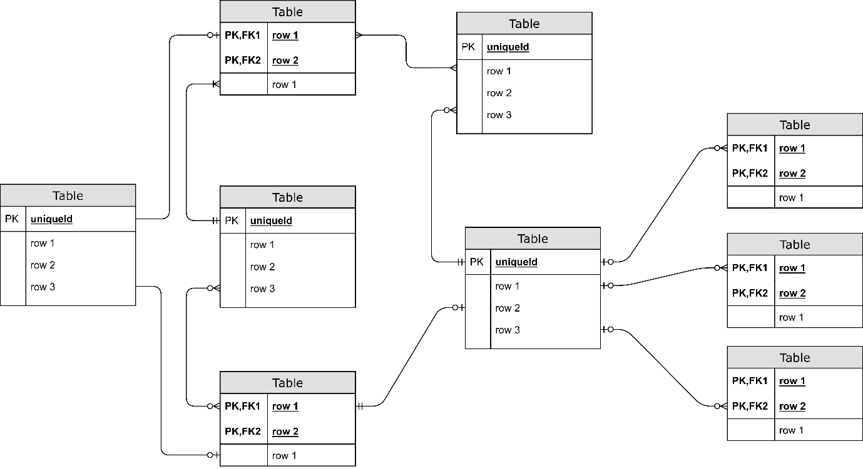
Figure 1 An example entity relationship diagram figure produced using draw.io's Entity Relationship template

This section must include:
- A conceptual design discussion
- A logical design discussion
- A physical design discussion
- A physical ERD design diagram using Crow’s Feet or Chen notation

This section could include:
- Conceptual design
  - A conceptual design discussion
  - A conceptual ERD design diagram using Crow’s Feet or Chen notation
- Logical design
  - A logical design discussion
  - A logical ERD design diagram using Crow’s Feet or Chen notation
- Physical design
  - A physical design discussion
  - A physical ERD design diagram using Crow’s Feet or Chen notation
- Physical prototyping
  - An initial prototype SQL script containing DDL / DML intended to create the above physical design structure and populate with example data
  - Some example SQL queries which demonstrate capabilities needed for the different features of the web service.

Planning and Design: Web Services
This section will present the different parts of the web service, with a particular focus on the individual web service endpoints (which will serve as functions), the URI/URL route they will be accessible at, the HTTP method(s) which can be used to access them, with examples of expected input(s) and expected output(s).

Endpoint | HTTP Method | Description | Example Input  (Request) | Example Output  (Response) | Status Code | Happy/  Sad
/api/v1/movies | GET | The API endpoint will retrieve a JSON object containing a list of movies stored within the database | N/A (Non applicable) | Here you would provide an example of the expected output data, in the form of the previously mentioned JSON object | 200 | Happy
/api/v1/movies | POST | The API endpoint will receive a JSON object containing information about a new movie we wish to store in the database | Request headers:  content-type application/json  Request Body:  {  “title”: “Face/Off Part Deux”,  “production company”: “Renaissance”  “director”: “Sam Raimi”,  “cast”: [  “Rip Torn”,  “Donald Sutherland”  ]  “writers”: [  “Conan O\’Brien”  ]  “release date” : {  “USA” : “20/11/2025”,  “Europe”: “27/11/2025”  }  } | Request headers:  content-type application/json  Response Body:  {  “response message”: “Movie added”  } | 201 | Happy
/api/v1/movies | POST | The API endpoint will receive an empty JSON object containing no information. As we cannot create a movie with no data, this operation will fail | Request headers:  content-type application/json  Request body:  {  } | Request headers:  content-type application/json  Response body:  {  “error message”: “could not add movie, request body format invalid”  } | 400 | Sad
Table 4 Resource URI inventory summary table

An example of a “main body discussion of initial prototype source code snippets” (see could include):
To help us refine our designs we have also attempted some small-scale prototyping and “experimentation” with the endpoints we have identified in the designs presented, this has allowed us to identify improvements with the overall design itself and how it can be implemented within the target programming language and framework. As we can see in snippet Code Snippet 1 within Appendix C Carmack’s initial attempt at programming the web api endpoint for accessing person records by id has a few issues, one of the most important being a possible SQL injection attack due to not properly constraining the input data for the endpoint and using that input data directly within an interpolated string to act as the SQL query. Sperry suggested that we could instead …

This section must include:
- A resource URI inventory including:
  - A Resource URI inventory summary table
  - A protocol specification detailing the communication process for each URI/endpoint defining what constitutes valid input (request) structures and valid output (response) structures.
- An accompanying main body of text which discusses and justifies the approach taken

This section could include:
- A main body discussion of initial prototype source code snippets for some of the different URI / Web API endpoints, with particular attention to the function/method signature (where applicable)

References
You would provide references to important sources which have been used to support your approach to the coursework here – note these sources should have been cited in the main body of text. References and citations should be in BCU’s Harvard Referencing format.

Appendices
An appendix is found at the end of a report, research project, or dissertation and contains any additional information which is relevant to the work but would interrupt the flow and structure of the main body of text. The information in the appendices is still relevant to your overall work and discussion but is considered too long or too detailed to include in the main body of your work, therefore your main body discussion should make note of what additional information is present about a particular topic of discussion and cross reference it with the relevant appendix.

Appendix A

Appendix B
…

Appendix C: Initial Prototyping and Source Code snippets

@app.route("/api/v1/person/<id>", methods=["GET"])
def person_byid_v1(id):
# Connecting to the database engine
with engine.connect() as conn:
query = text(f"SELECT * FROM PERSON WHERE id={id}")
output = conn.execute(query).fetchall()
# SQL Alchemy rows cannot be converted directly into json objects
tuples_result = [tuple(row) for row in output]
json_result = jsonify(tuples_result)
return json_result, 200 # returning a JSONified response along with the status code
Code Snippet 1 Initial attempt to access individual person records based on their ID, though vulnerable to SQL Injection

Appendix D
…

Appendix E
…

Appendix F
…

Appendix G
…

Appendix Z

